**Ideation Phase**

**Define the Problem Statements**

|  |  |
| --- | --- |
| Date | 31 January 2025 |
| Team ID | LTVIP2025TMID32163 |
| Project Name | Smart SDLC – AI Enhanced Software Development Lifecycle |
| Maximum Marks | 2 Marks |

### ****Customer Problem Statement Template: Smart SDLC****

**Understand your users’ perspective and build AI-powered software development experiences they’ll value.**

Smart SDLC is a generative AI-powered application built using FastAPI and IBM's Granite-3.3-2b-instruct model. It offers intelligent, phase-wise assistance across the Software Development Life Cycle (SDLC), empowering developers, educators, and learners with guided insights and automation.

A well-crafted customer problem statement helps your team focus on solving the right challenges in modern software development. Smart SDLC addresses these challenges by simplifying SDLC practices, reducing manual effort, and making engineering knowledge more accessible through AI.

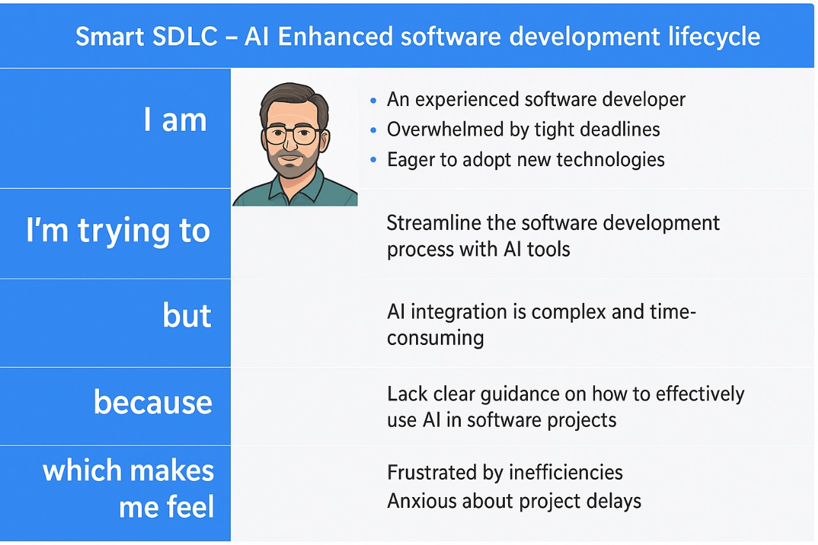

Reference: <https://miro.com/templates/customer-problem-statement/>

**Example:**

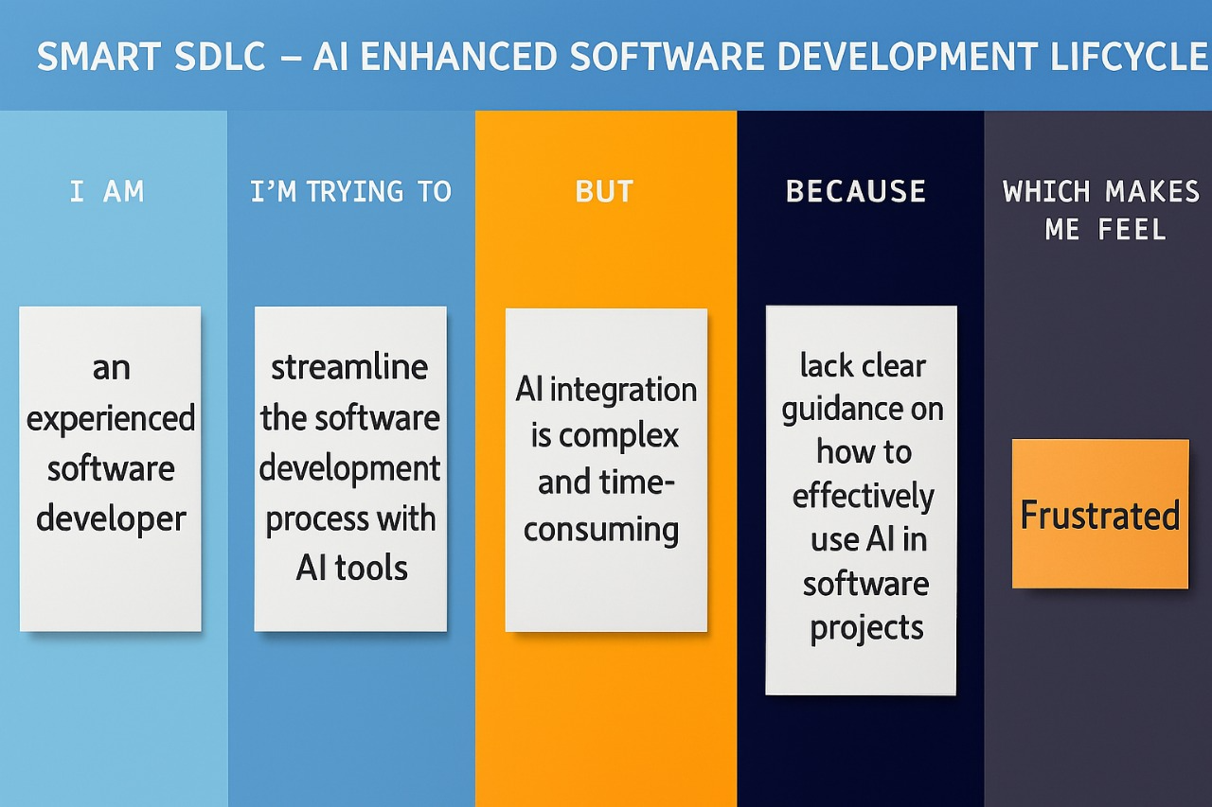

|  |  |  |  |  |  |
| --- | --- | --- | --- | --- | --- |
| **Problem Statement (PS)** | **I am (Customer)** | **I’m trying to** | **But** | **Because** | **Which makes me feel** |
| PS-1 |  |  |  |  |  |
| PS-2 |  |  |  |  |  |